Austin Traffic Fatalities 2013-2018

September 12, 2019

By: Jennifer Lawless, Jie Bai, Jorge Cavazos, Tristan Serigny

**Initial Considerations:**

For our project we will be analyzing Austin's traffic fatalities over the last six years. We will be examining several factors involved in these traffic fatalities (location time, vehicle types, cause of the accident, sobriety, and seatbelt usage). Our data comes from data.austintexas.gov and we are basing our project on data sets provided from APD traffic reports. Through our data mining and analysis, we hope to produce readable analysis and visualization that will:

* Map the specific locations of Austin traffic fatalities
* Determine the most common cause, vehicle type and time of day involved in these accidents
* Compare the total number of these accidents among each year over the six year span our data set provides
* Determine the percentage of these accidents occurred while the driver was wearing a seat belt and vice versa
* Determine the percentage of these accidents occurred while the driver was sober and vice versa

**Dataset used:**

* City of Austin Open Data Portal: <https://data.austintexas.gov/browse?limitTo=datasets&q=traffic+fatalities&sortBy=relevance>

**Data Limitations:**

* Initially, we were going to include 2012 in the analysis, however, the dataset was not as detailed as the other years and did not include categories we were interested in, such as sobriety or seatbelt usage.

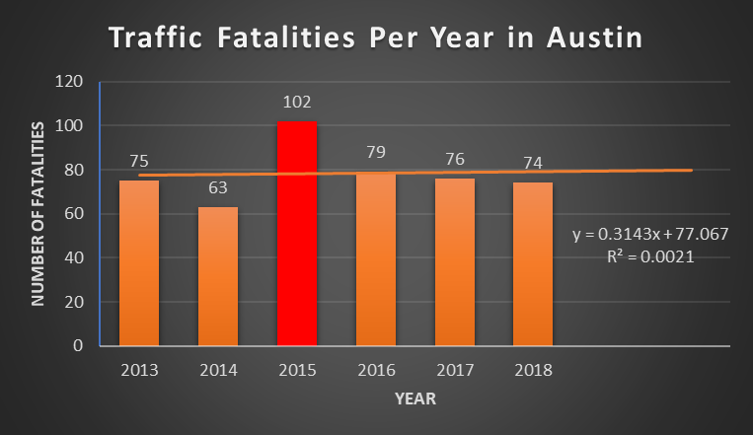

**Where do most traffic fatalities occur?**

* We can see a shift from 2013, where the number of fatalities were more spread out along major roads and highways in Austin, to 2018, where the most fatalities occurred along the I-35 corridor near Highways 183 & 290, downtown, and again near Slaughter Ln.
* As Austin’s population continues to grow, the need to expand and improve major roads and highways continues to be an issue and construction projects likely contribute to some dangerous conditions.

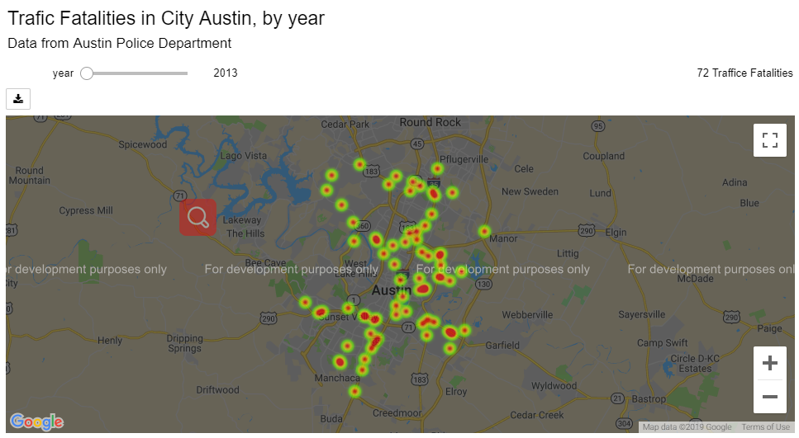

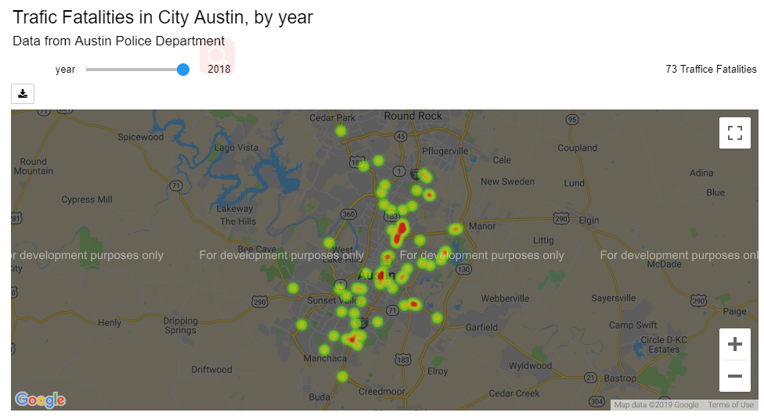

**What time of day do most accidents occur?**

* There is a definite trend towards late evening and early morning, when people are more likely to be either tired or intoxicated, with a peak fatality rate between 2-2:30am (when bars close).

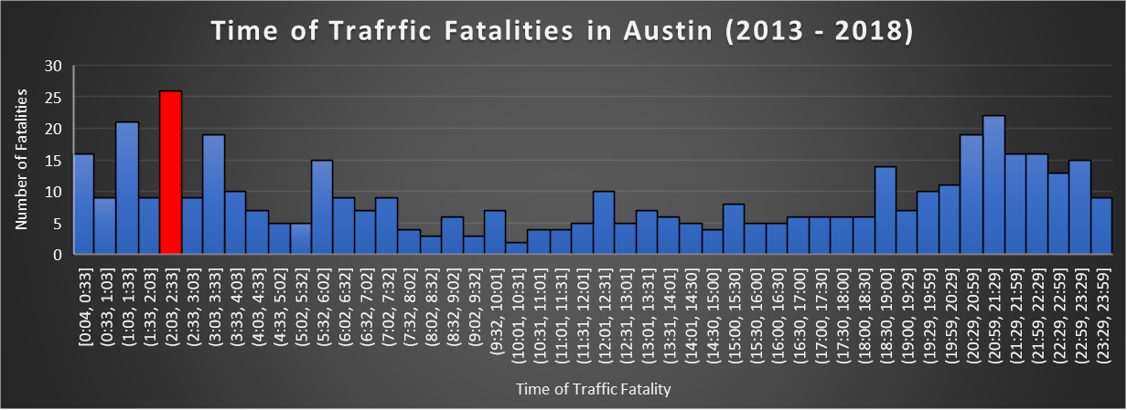

**What are the most common vehicles in traffic fatalities?**

* Motor vehicles, such as cars or trucks, were the most common, simply because there are more of them on the roads. The specific make and model of the vehicles were not available in our dataset, but it would be interesting to see if that would make a difference.

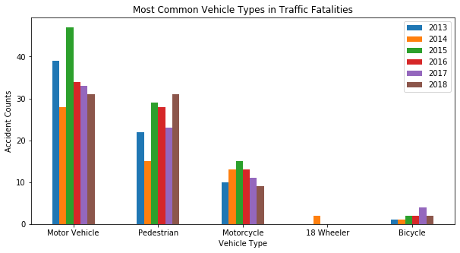

**What are the main reasons for traffic fatalities?**

* Impairment, speeding, running stop signs or red lights, and not wearing a seatbelt, or any combination of these, are the main causes.

**What percent of fatalities occurred while the driver was sober and not sober?**

**What percent of fatalities occurred when seatbelts were worn?**

* More fatalities occurred when seatbelts were worn than when they were not worn, so we can not conclude that seatbelts made a significant impact on the number of fatalities.

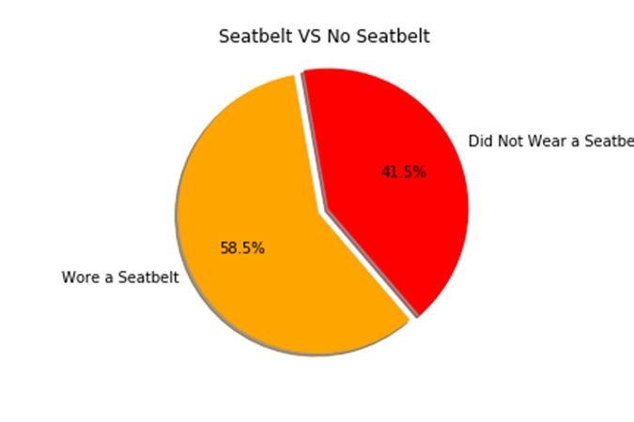

**Conclusions and future implications:**

* The number of traffic fatalities in Austin appear to be decreasing over the last few years for motor vehicles and motorcycles but appear to be trending upwards for pedestrians and bicyclists.
* Austin is growing in population every day and we all know traffic seems to be getting worse, and with more people, unfortunately, comes the higher risk of accidents.